# Workshop: End To End – Quiz System Fever

Workshop problem for the ["JavaScript Applications" course @ SoftUni](https://softuni.bg/trainings/3488/js-applications-october-2021).

GitHub Resources: <https://github.com/quiz-fever/quiz-fever.github.io>.

## Overview

**Implement** an application to see and manage the **system for creating, managing, and completing free access tests**. The app allows visitors to **browse** different types of quizzes. Users can **register** with an **email**, a **username**, and a **password**, which allows them to create their own quizzes. Authors can also **edit** or **delete** their quizzes at any time.

## Functionality

The app **should** have:

* **Login** and **Register**
* Ability to **view** and solve **quizzes** by other users
* Various **topics** related
* Ability to **filter** by topic and **search** by title
* **Statistics** for each user and each quiz
* Interactive quiz editor
* Interactive UX

You **should** use:

* HTML, CSS, JavaScript
* lit-html, page.js
* GitHub Pages, Back4app

## Implementation

Create Back4app app. You can see the documentation on Users here:  
<https://www.back4app.com/docs/get-started/read-and-write-data>

Use Back4app for your collection:

* Sessions
* Users

{

email: String,

username: String,

password: String

}

* Quizzes

{

title: String,

topic: String,

questionCount: Number

}

* Questions

{

text: String,

answers: Array<String>,

correctIndex: Number,

quiz: Pointer<Quiz>

}

* Solutions

{

quiz: Pointer<Quiz>,

correct: Number

}

## Application Requirements

### Navigation Bar

**Navigation** links should correctly change the current page (view). The **Quiz Fever** link should redirect to the Welcome Screen.

A **Guest** (un-authenticated visitors) can see the links to the **Browse** page, as well as the link to the **Sign-in** page.



The **logged-in** user navbar should contain the links to the **Browse** page, the **Create** page, the **Profile** page, and a link for a **Logout** action.



### Login User

The **Login** page contains a form for existing user authentication. By providing a **username** and a **password**, the user can log in in the system. The form should **not accept any empty fields**.

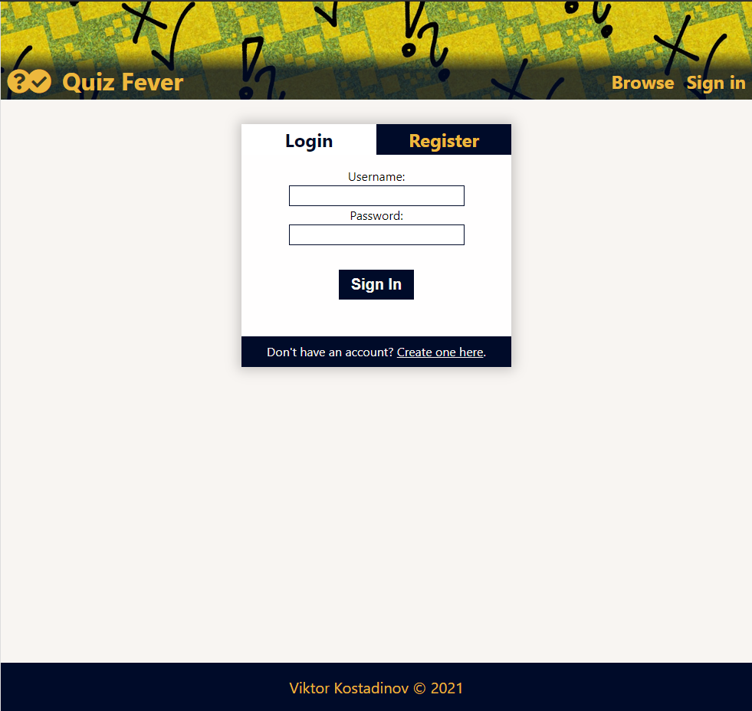

### Register User

The **Register** page contains a form for new user registration. By providing an **email**, a **username**, and a **password**, the app should **register a new user** in the system if there are no empty fields.

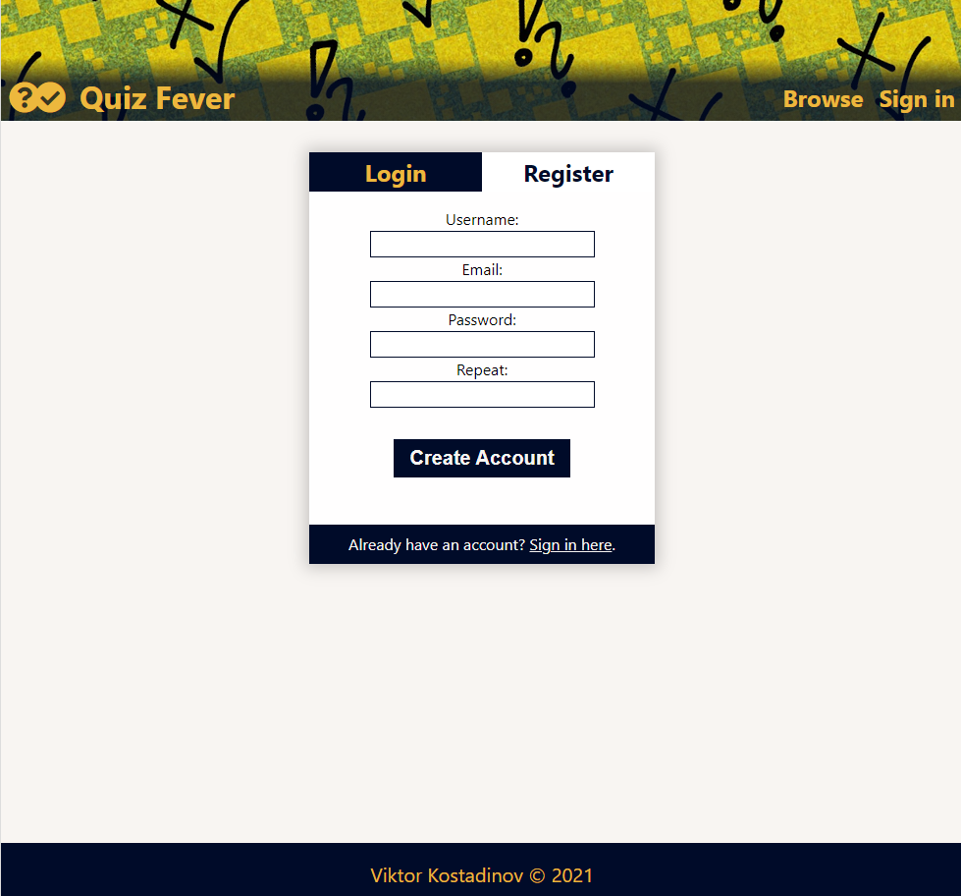

### Logout

The **logout** action is available to logged-in users.

### Welcome Screen

All users should be greeted from the **loading** page, where they should be able to see the most **recent** **quizzes** and button for all other quizzes.

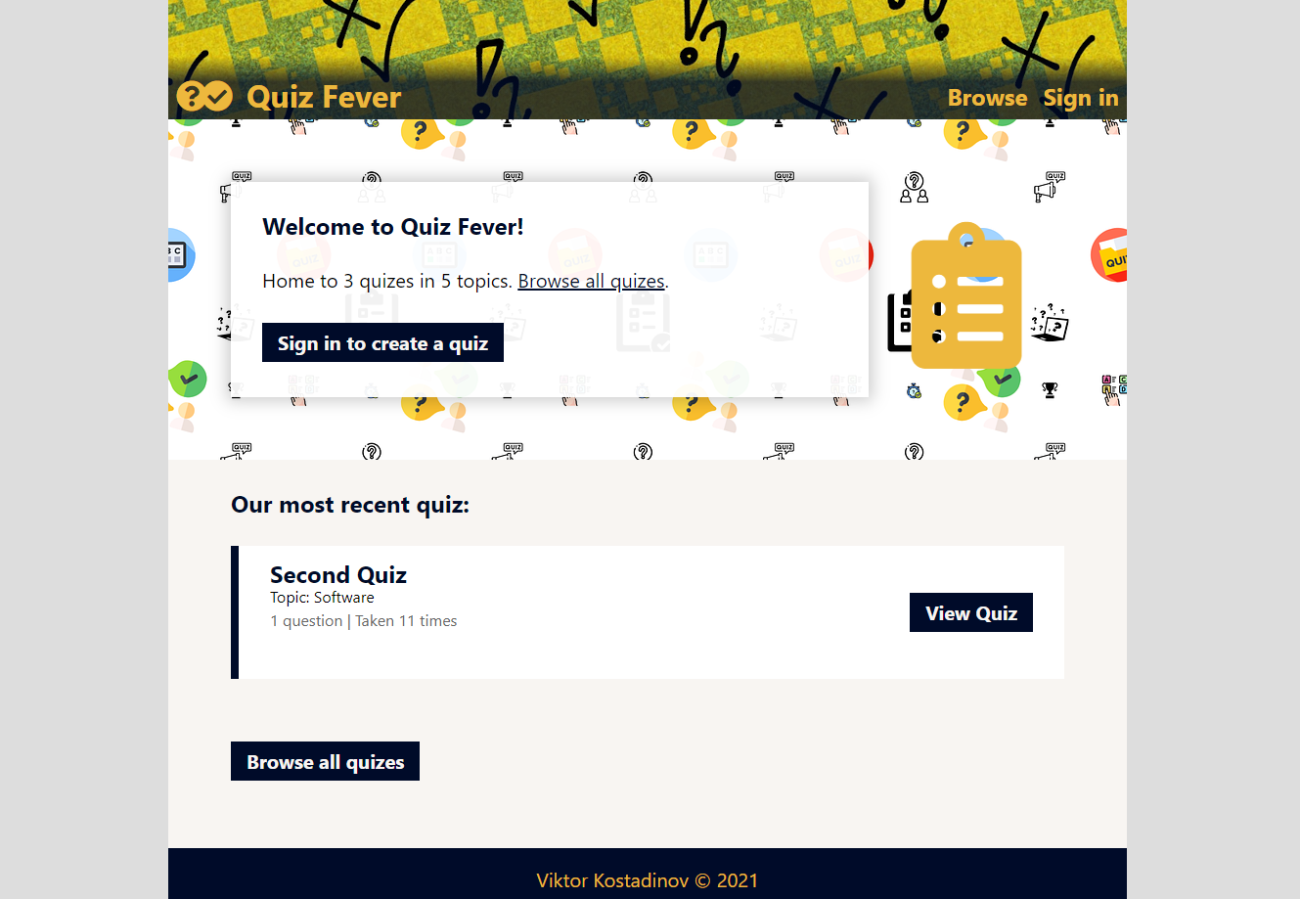

### Quiz Browser

The **Quiz Browser** page includes a **list of quizzes**, and it's possible to **search** by titles and **filter** by topics. All **visitors** (Guests or Users) can view the **catalog**.

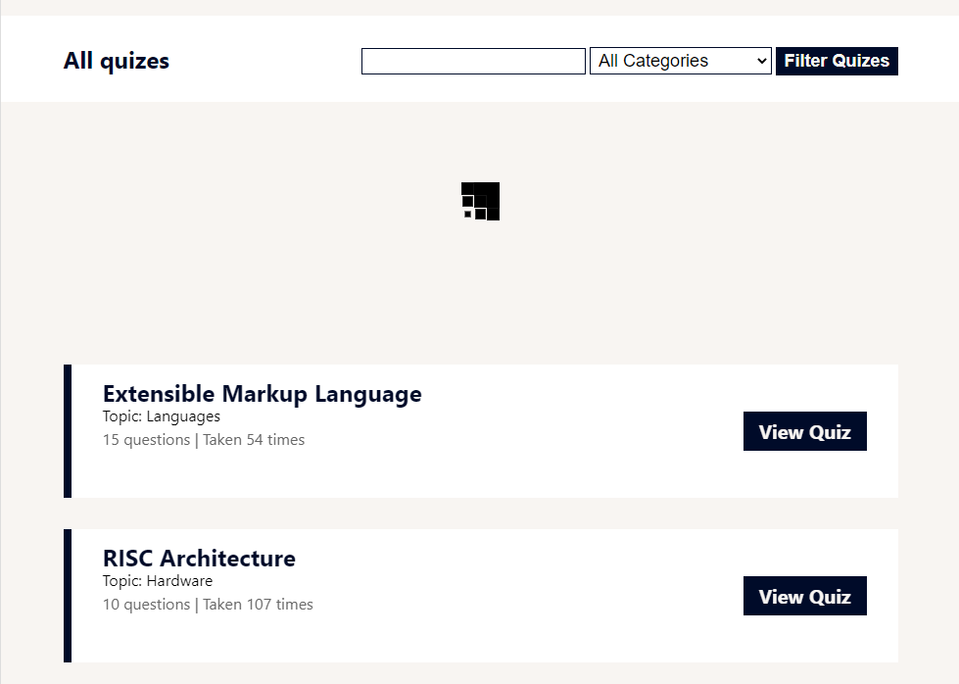

### Quiz Details

The **Quiz Details** page contains the quiz' **description**, **statistics**, author **information**, and a **start** button. All **visitors** (Guests or Users) can view the **details**. But only **Users** can **solve** quizzes.



### Quiz Contest Mode

The **Contest Mode** page contains **questions** and their **answers**. Every question has a separate view and an opportunity for **passage** from one question to another. There is a possibility to **restart** the test at any moment.

Only **registered** users can **solve** quizzes and view their **results**.

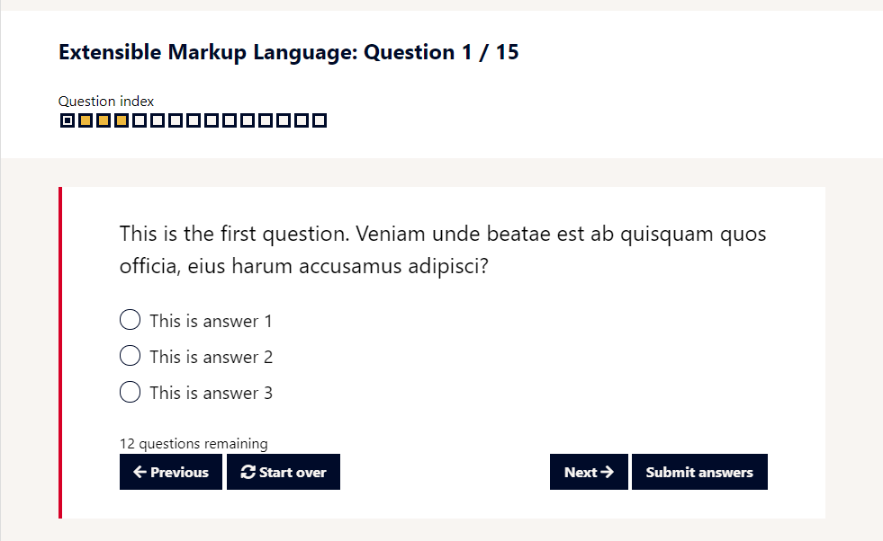

### Quiz Result

The **Quiz Result** page contains a **summary** of the result and an opportunity to review the **wrong** questions.

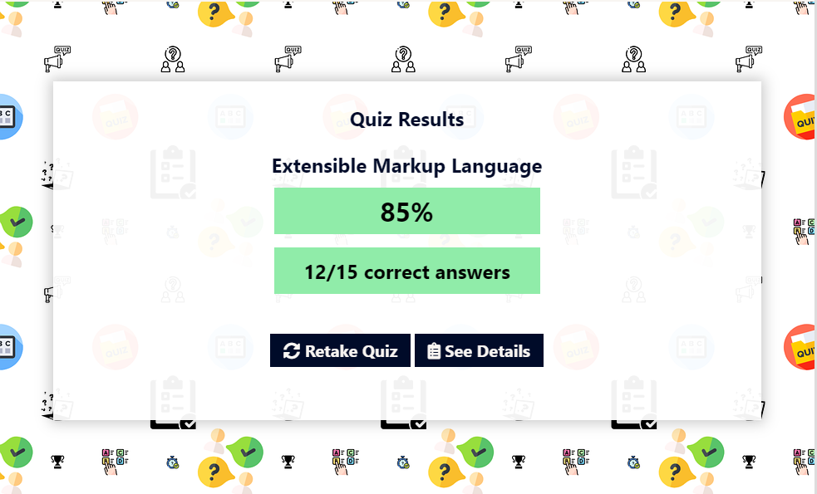

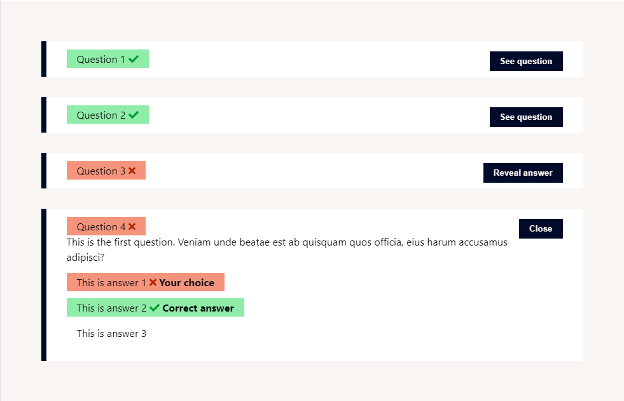

### Profile Page

The **Profile** page holds **information** for all created and solved quizzes. All **visitors** (Guests or Users) can view creators' **profile** pages.

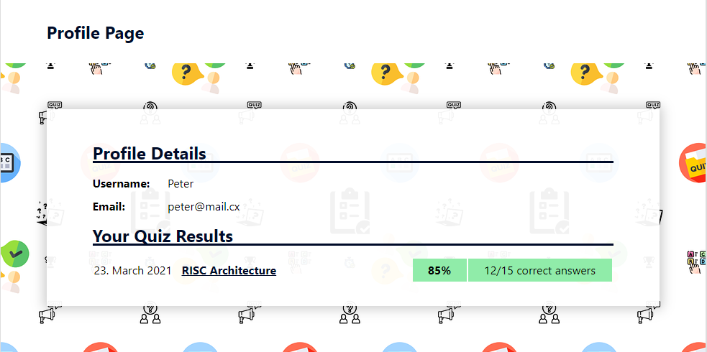

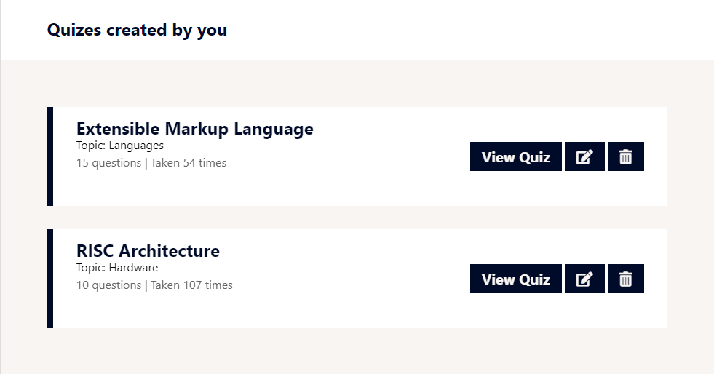

### Quiz Editor

The **Quiz Editor** page is an integrated editor for tests, questions, and answers. Only the quiz' **creator** has access to this page and has the opportunity to **edit** and **delete** questions.

